UNIT II WIRLESS LAN
Topics to be covered:
1.Wireless LAN, 2.IEEE 802.11, Architecture, Services, MAC, Physical layer, 3.IEEE 802.11a , 802.11b standards, 4.HIPERLAN, 5.Blue Tooth.
1. Wireless LAN:
This chapter presents several wireless local area network (WLAN) technologies. This constitutes a fast-growing market introducing the flexibility of wireless access into office, home, or production environments. WLANs are typically restricted in their diameter to buildings, a campus, single rooms etc. and are operated by individuals, not by large-scale network providers. The global goal of WLANs is to replace office cabling, to enable secured access to the internet and, to introduce a higher flexibility for ad-hoc communication in, e.g., group meetings.

Some advantages of WLANs are:

- Flexibility
- Planning
- Design
- Robustness
- Cost

But WLANs also have several disadvantages:

- Quality of service
- Proprietary solutions
- Restrictions
- Safety and security

Many different, and sometimes competing, design goals have to be taken into account for WLANs to ensure their commercial success:

- Global operation
- Low power
- License-free operation
- Robust transmission technology
- Simplified spontaneous cooperation
- Easy to use
- Protection of investment
- Safety and security
- Transparency for applications

The following sections first introduce basic transmission technologies used for WLANs, infra red and radio, then the two basic settings for WLANs: infrastructure- based and ad-hoc, are presented.

1.1 Infra red vs radio transmission:
Today, two different basic transmission technologies can be used to set up WLANs. One technology is based on the transmission of infra red light (e.g., at 900 nm wavelength), the other one, which is much more popular, uses radio transmission in the GHz range (e.g., 2.4 GHz in the license-free ISM band). Both technologies can be used to set up ad-hoc connections for work groups, to connect, e.g., a desktop with a printer without a wire, or to support mobility within a small area.
Infra red technology uses diffuse light reflected at walls, furniture etc. or directed light if a line-of-sight (LOS) exists between sender and receiver. Senders can be simple light emitting diodes (LEDs) or laser diodes. Photodiodes act as receivers.

Advantages:
- Simple and extremely cheap
- PDAs, laptops, notebooks, mobile phones etc. have an infra red data association (IrDA) interface.
- Version 1.0 of this industry standard implements data rates of up to 115 kbit/s, while IrDA 1.1 defines higher data rates of 1.152 and 4 Mbit/s.
- No licenses are needed for infra red technology and shielding is very simple. Electrical devices do not interfere with infra red transmission.

Disadvantages:
- Low bandwidth compared to other LAN technologies.
- IrDA devices are internally connected to a serial port limiting transfer rates to 115 kbit/s. Even 4 Mbit/s is not a particularly high data rate.
- Infra red is quite easily shielded. Infra red transmission cannot penetrate walls or other obstacles. Typically, for good transmission quality and high data rates a LOS, i.e., direct connection, is needed.

Almost all networks use radio waves for data transmission, e.g., GSM at 900, 1,800, and 1,900 MHz, DECT at 1,880 MHz etc.

Advantages:
- The long-term experiences made with radio transmission for wide area networks (e.g., microwave links) and mobile cellular phones.
- Radio transmission can cover larger areas and can penetrate (thinner) walls, furniture, plants etc.
- Additional coverage is gained by reflection.
- Radio typically does not need a LOS if the frequencies are not too high.
- Furthermore, current radio-based products offer much higher transmission rates (e.g., 54 Mbit/s) than infra red (directed laser links, which offer data rates well above 100 Mbit/s. These are not considered here as it is very difficult to use them with mobile devices).

Disadvantages:
- Shielding is not so simple.
- Radio transmission can interfere with other senders, or electrical devices can destroy data transmitted via radio.
- Radio transmission is only permitted in certain frequency bands. Very limited ranges of license-free bands are available worldwide and those that are available are not the same in all countries.

Of the three WLAN technologies presented in this chapter, only IEEE 802.11 use standardized infra red transmission in addition to radio transmission. The other two (HIPERLAN and Bluetooth) rely on radio.

1.2 Infrastructure and ad-hoc networks
Many WLANs of today need an infrastructure network. Infrastructure networks not only provide access to other networks, but also include forwarding functions, medium access control etc. In these infrastructure-based wireless networks, communication typically takes place only between the wireless nodes and the access point, but not directly between the wireless nodes.
The access point does not just control medium access, but also acts as a bridge to other wireless or wired networks. Figure, shows three access points with their three wireless networks and a wired network. Several wireless networks may form one logical wireless network, so the access points together with the fixed network in between can connect several wireless networks to form a larger network beyond actual radio coverage.

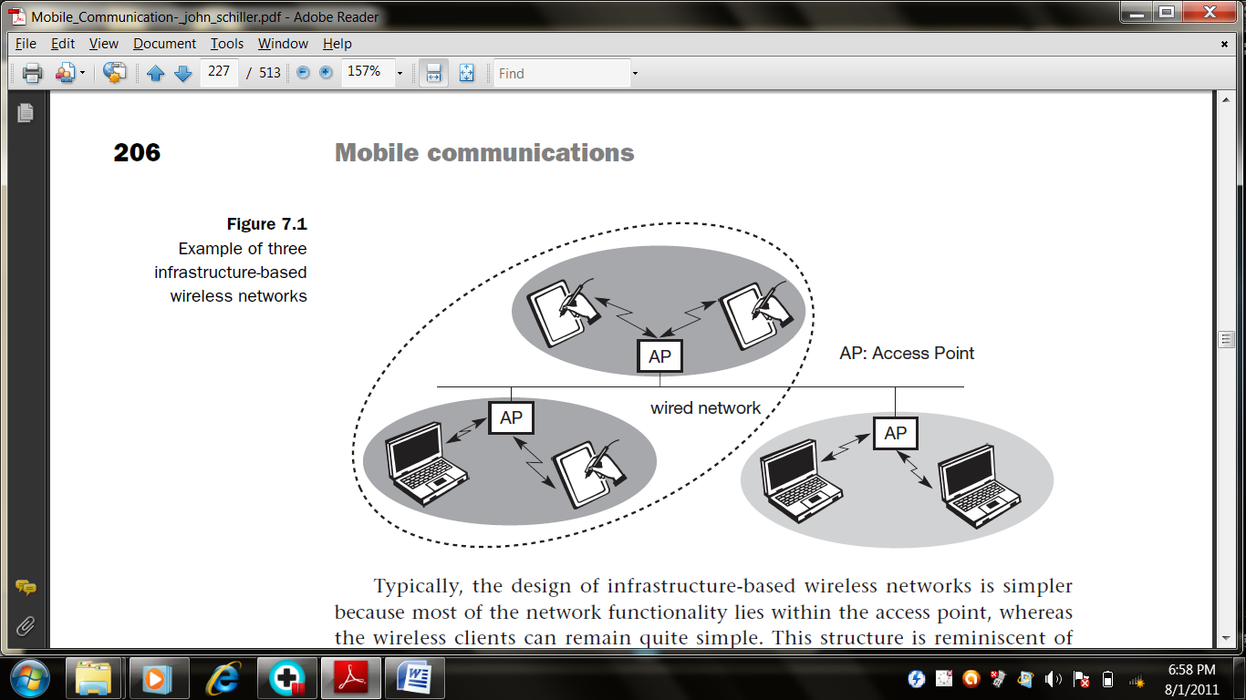
Typically, the design of infrastructure-based wireless networks is simpler because most of the network functionality lies within the access point, whereas the wireless clients can remain quite simple. This structure is reminiscent of switched Ethernet or other star-based networks, where a central element (e.g., a switch) controls network flow. This type of network can use different access schemes with or without collision. Collisions may occur if medium access of the wireless nodes and the access point is not coordinated. However, if only the access point controls medium access, no collisions are possible. This setting may be useful for quality of service guarantees such as minimum bandwidth for certain nodes. The access point may poll the single wireless nodes to ensure the data rate.
Infrastructure-based networks lose some of the flexibility wireless networks can offer, e.g., they cannot be used for disaster relief in cases where no infrastructure is left. Typical cellular phone networks are infrastructure-based networks for a wide area. Also satellite-based cellular phones have an infrastructure – the satellites. Infrastructure does not necessarily imply a wired fixed network.
Ad-hoc wireless networks, however, do not need any infrastructure to work. Each node can communicate directly with other nodes, so no access point controlling medium access is necessary. Figure, shows two ad-hoc networks with three nodes each. Nodes within an ad-hoc network can only communicate if they can reach each other physically, i.e., if they are within each other’s radio range or if other nodes can forward the message. Nodes from the two networks shown in Figure, cannot, therefore, communicate with each other if they are not within the same radio range.
In ad-hoc networks, the complexity of each node is higher because every node has to implement medium access mechanisms, mechanisms to handle hidden or exposed terminal problems, and perhaps priority mechanisms, to provide a certain quality of service. This type of wireless network exhibits the greatest possible flexibility as it is, for example, needed for unexpected meetings, quick replacements of infrastructure or communication scenarios far away from any infrastructure.
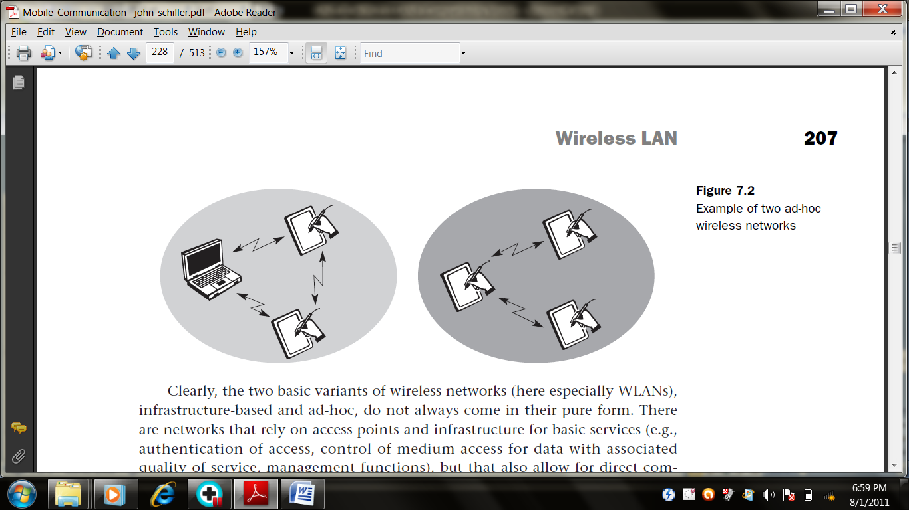

Clearly, the two basic variants of wireless networks (here especially WLANs), infrastructure-based and ad-hoc, do not always come in their pure form. There are networks that rely on access points and infrastructure for basic services (e.g., authentication of access, control of medium access for data with associated quality of service, management functions), but that also allow for direct communication between the wireless nodes. However, ad-hoc networks might only have selected nodes with the capabilities of forwarding data. Most of the nodes have to connect to such a special node first to transmit data if the receiver is out of their range. From the three WLANs presented, IEEE 802.11 and HiperLAN2 are typically infrastructure-based networks, which additionally support ad-hoc networking. However, many implementations only offer the basic infrastructure-based version. The third WLAN, Bluetooth, is a typical wireless ad-hoc network. Bluetooth focuses precisely on spontaneous ad-hoc meetings or on the simple connection of two or more devices without requiring the setup of an infrastructure.

2. IEEE 802.11
The IEEE standard 802.11 specifies the most famous family of WLANs in which many products are available. As the standard’s number indicates, this standard belongs to the group of 802.x LAN standards, e.g., 802.3 Ethernet or 802.5 Token Ring. This means that the standard specifies the physical and medium access layer adapted to the special requirements of wireless LANs, but offers the same interface as the others to higher layers to maintain interoperability.
The primary goal of the standard was the specification of a simple and robust WLAN which offers time-bounded and asynchronous services. The MAC layer should be able to operate with multiple physical layers, each of which exhibits a different medium sense and transmission characteristic. Candidates for physical layers were infra red and spread spectrum radio transmission techniques.
Additional features of the WLAN should include the support of power management to save battery power, the handling of hidden nodes, and the ability to operate worldwide. The 2.4 GHz ISM band, which is available in most countries around the world, was chosen for the original standard. Data rates envisaged for the standard were 1 Mbit/s mandatory and 2 Mbit/s optional.
The following sections will introduce the system and protocol architecture of the initial IEEE 802.11 and then discuss each layer, i.e., physical layer and medium access. After that, the complex and very important management functions of the standard are presented.

2.1 System architecture
Wireless networks can exhibit two different basic system architectures. It may be either infrastructure-based or ad-hoc. Following figure shows the components of an infrastructure and a wireless part as specified for IEEE 802.11. Several nodes, called stations (STAi), are connected to access points (AP). Stations are terminals with access mechanisms to the wireless medium and radio contact to the AP. The stations and the AP which are within the same radio coverage form a basic service set (BSSi). The example shows two BSSs – BSS1 and BSS2 – which are connected via a distribution system.
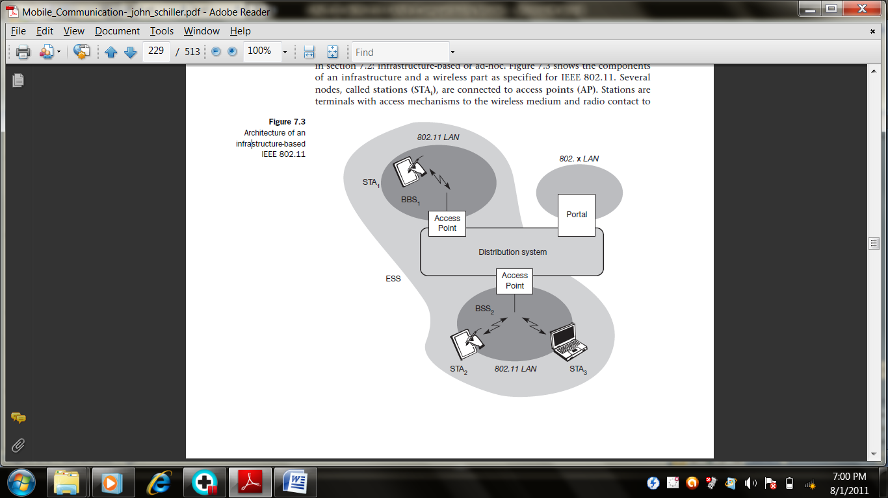
A distribution system connects several BSSs via the AP to form a single network and thereby extends the wireless coverage area. This network is now called an extended service set (ESS) and has its own identifier, the ESSID. The ESSID is the ‘name’ of a network and is used to separate different networks. Without knowing the ESSID (and assuming no hacking) it should not be possible to participate in the WLAN. The distribution system connects the wireless networks via the APs with a portal, which forms the interworking unit to other LANs.
The architecture of the distribution system is not specified further in IEEE 802.11. It could consist of bridged IEEE LANs, wireless links, or any other networks. However, distribution system services are defined in the standard. Stations can select an AP and associate with it. The APs support roaming (i.e., changing access points), the distribution system handles data transfer between the different APs. APs provide synchronization within a BSS, support power management, and can control medium access to support time-bounded service. These and further functions are explained in the following sections. In addition to infrastructure-based networks, IEEE 802.11 allows the building of ad-hoc networks between stations, thus forming one or more independent BSSs (IBSS) as shown in Figure. In this case, an IBSS comprises a group of stations using the same radio frequency. Stations STA1, STA2, and STA3 are in IBSS1, STA4 and STA5 in IBSS2. This means for example that STA3 can communicate directly with STA2 but not with STA5.

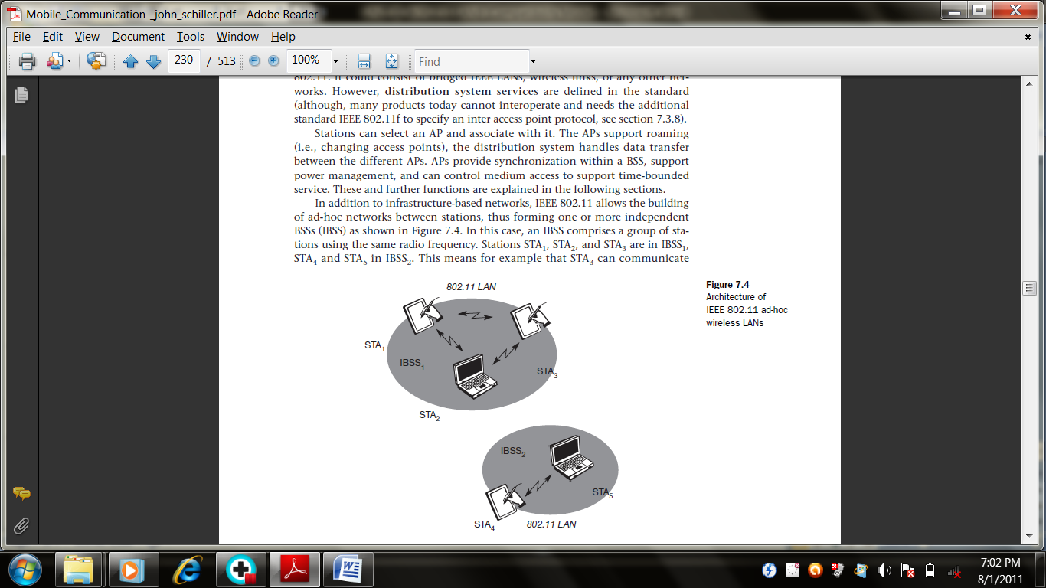
Several IBSSs can either be formed via the distance between the IBSSs or by using different carrier frequencies (then the IBSSs could overlap physically). IEEE 802.11 does not specify any special nodes that support routing, forwarding of data or exchange of topology information as, e.g., HIPERLAN 1 or Bluetooth.

2.2. Protocol architecture
As indicated by the standard number, IEEE 802.11 fits seamlessly into the other 802.x standards for wired LANs. Figure, shows the most common scenario: an IEEE 802.11 wireless LAN connected to a switched IEEE 802.3 Ethernet via a bridge. Applications should not notice any difference apart from the lower bandwidth and perhaps higher access time from the wireless LAN. The WLAN behaves like a slow wired LAN. Consequently, the higher layers (application, TCP, IP) look the same for wireless nodes as for wired nodes. The upper part of the data link control layer, the logical link control (LLC), covers the differences of the medium access control layers needed for the different media. In many of today’s networks, no explicit LLC layer is visible.
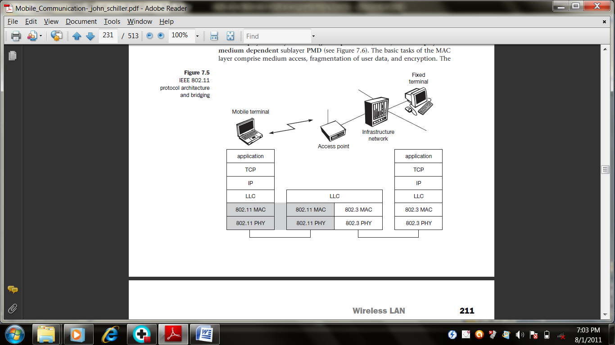
The IEEE 802.11 standard only covers the physical layer PHY and medium access layer MAC like the other 802.x LANs do. The physical layer is subdivided into the physical layer convergence protocol (PLCP) and the physical medium dependent sublayer PMD. The basic tasks of the MAC layer comprise medium access, fragmentation of user data, and encryption.
The PLCP sublayer provides a carrier sense signal, called clear channel assessment (CCA), and provides a common PHY service access point (SAP) independent of the transmission technology. Finally, the PMD sublayer handles modulation and encoding/decoding of signals. The PHY layer (comprising PMD and PLCP) and the MAC layer will be explained in more detail in the following sections.
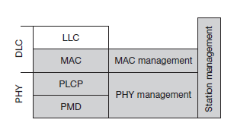
Apart from the protocol sublayers, the standard specifies management layers and the station management. The MAC management supports the association and re-association of a station to an access point and roaming between different access points. It also controls authentication mechanisms, encryption, synchronization of a station with regard to an access point, and power management to save battery power. MAC management also maintains the MAC management information base (MIB).
The main tasks of the PHY management include channel tuning and PHY MIB maintenance. Finally, station management interacts with both management layers and is responsible for additional higher layer functions (e.g., control of bridging and interaction with the distribution system in the case of an access point).

2.3 Physical layer
IEEE 802.11 supports three different physical layers: one layer based on infra red and two layers based on radio transmission. All PHY variants include the provision of the clear channel assessment signal (CCA). This is needed for the MAC mechanisms controlling medium access and indicates if the medium is currently idle. The transmission technology (which will be discussed later) determines exactly how this signal is obtained.
The PHY layer offers a service access point (SAP) with 1 or 2 Mbit/s transfer rate to the MAC layer (basic version of the standard). The remainder of this section presents the three versions of a PHY layer defined in the standard.

2.3.1 Frequency hopping spread spectrum
Frequency hopping spread spectrum (FHSS) is a spread spectrum technique which allows for the coexistence of multiple networks in the same area by separating different networks using different hopping sequences. The original standard defines 79 hopping channels for North America and Europe, and 23 hopping channels for Japan (each with a bandwidth of 1 MHz in the 2.4 GHz ISM band). The selection of a particular channel is achieved by using a pseudo-random hopping pattern. Figure shows a frame of the physical layer used with FHSS. The frame consists of two basic parts, the PLCP part (preamble and header) and the payload part. While the PLCP part is always transmitted at 1 Mbit/s, payload, i.e. MAC data, can use 1 or 2 Mbit/s.
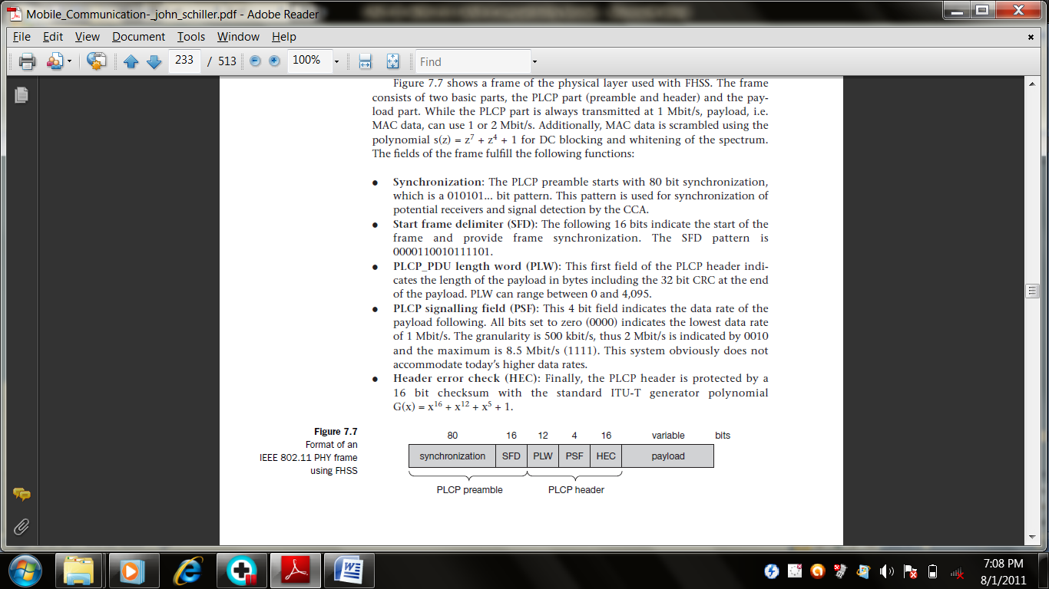

The fields of the frame fulfill the following functions:
- Synchronization: The PLCP preamble starts with 80 bit synchronization, which is a 010101... bit pattern. This pattern is used for synchronization of potential receivers and signal detection by the CCA.
- Start frame delimiter (SFD): The following 16 bits indicate the start of the frame and provide frame synchronization. The SFD pattern is 0000110010111101.
- PLCP_PDU length word (PLW): This first field of the PLCP header indicates the length of the payload in bytes including the 32 bit CRC at the end of the payload. PLW can range between 0 and 4,095.
- PLCP signalling field (PSF): This 4 bit field indicates the data rate of the payload following. All bits set to zero (0000) indicates the lowest data rate of 1 Mbit/s. The granularity is 500 kbit/s, thus 2 Mbit/s is indicated by 0010 and the maximum is 8.5 Mbit/s (1111). This system obviously does not accommodate today’s higher data rates.
- Header error check (HEC): Finally, the PLCP header is protected by a 16 bit checksum with the standard ITU-T generator polynomial G(x) = x16 + x12 + x5 + 1.

2.3.2 Direct sequence spread spectrum
Direct sequence spread spectrum (DSSS) is the alternative spread spectrum method separating by code and not by frequency. In the case of IEEE 802.11 DSSS, spreading is achieved using the 11-chip Barker sequence (+1, –1, +1, +1, –1, +1, +1, +1, –1, –1, –1). The key characteristics of this method are its robustness against interference and its insensitivity to multipath propagation (time delay spread). However, the implementation is more complex compared to FHSS.IEEE 802.11 DSSS PHY also uses the 2.4 GHz ISM band and offers both 1 and 2 Mbit/s data rates. The system uses differential binary phase shift keying (DBPSK) for 1 Mbit/s transmission and differential quadrature phase shift keying (DQPSK) for 2 Mbit/s as modulation schemes. Figure, shows a frame of the physical layer using DSSS. The frame consists of two basic parts, the PLCP part (preamble and header) and the payload part. While the PLCP part is always transmitted at 1 Mbit/s, payload, i.e., MAC data, can use 1 or 2 Mbit/s.
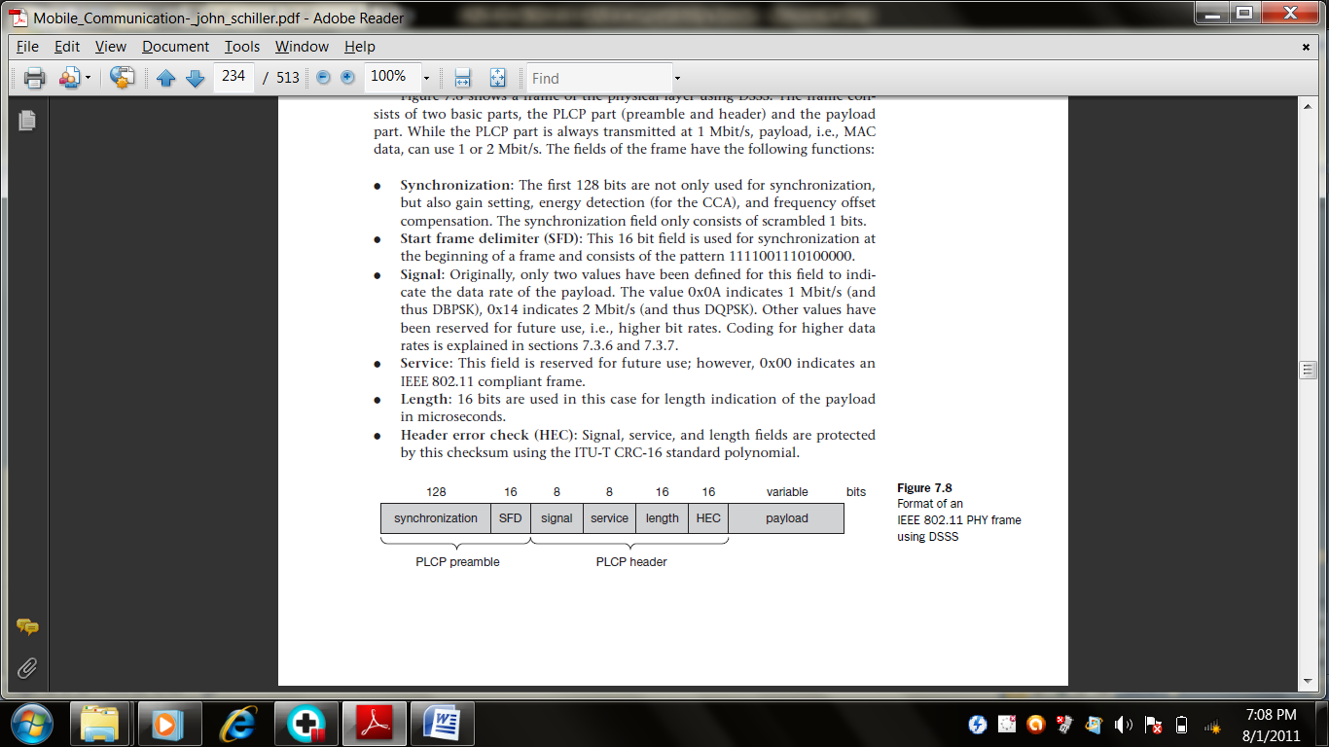
The fields of the frame have the following functions:
- Synchronization: The first 128 bits are not only used for synchronization, but also gain setting, energy detection (for the CCA), and frequency offset compensation. The synchronization field only consists of scrambled 1 bits.
- Start frame delimiter (SFD): This 16 bit field is used for synchronization at the beginning of a frame and consists of the pattern 1111001110100000.
- Signal: Originally, only two values have been defined for this field to indicate the data rate of the payload. The value 0x0A indicates 1 Mbit/s (and thus DBPSK), 0x14 indicates 2 Mbit/s (and thus DQPSK). Other values have been reserved for future use, i.e., higher bit rates.
- Service: This field is reserved for future use; however, 0x00 indicates an IEEE 802.11 compliant frame.
- Length: 16 bits are used in this case for length indication of the payload in microseconds.
- Header error check (HEC): Signal, service, and length fields are protected by this checksum using the ITU-T CRC-16 standard polynomial.

2.3.3 Infra red
The PHY layer, which is based on infra red (IR) transmission, uses near visible light at 850–950 nm. Infra red light is not regulated apart from safety restrictions (using lasers instead of LEDs). The standard does not require a line-of-sight between sender and receiver, but should also work with diffuse light. This allows for point-to-multipoint communication. The maximum range is about 10 m if no sunlight or heat sources interfere with the transmission. Typically, such a network will only work in buildings, e.g., classrooms, meeting rooms etc.

2.4 Medium access control layer
The MAC layer has to fulfill several tasks. First of all, it has to control medium access, but it can also offer support for roaming, authentication, and power conservation. The basic services provided by the MAC layer are the mandatory asynchronous data service and an optional time-bounded service. While 802.11 only offers the asynchronous service in ad-hoc network mode, both service types can be offered using an infrastructure-based network together with the access point coordinating medium access. The asynchronous service supports broadcast and multi-cast packets, and packet exchange is based on a ‘best effort’ model, i.e., no delay bounds can be given for transmission.
The following three basic access mechanisms have been defined for IEEE 802.11: the mandatory basic method based on a version of CSMA/CA, an optional method avoiding the hidden terminal problem, and finally a contention- free polling method for time-bounded service. The first two methods are also summarized as distributed coordination function (DCF), the third method is called point coordination function (PCF). DCF only offers asynchronous service, while PCF offers both asynchronous and time-bounded service but needs an access point to control medium access and to avoid contention.
The MAC mechanisms are also called distributed foundation wireless medium access control (DFWMAC). For all access methods, several parameters for controlling the waiting time before medium access are important. There are three different parameters that define the priorities of medium access.
- Short inter-frame spacing (SIFS): The shortest waiting time for medium access (so the highest priority) is defined for short control messages, such as acknowledgements of data packets or polling responses. For DSSS SIFS is 10 μs and for FHSS it is 28 μs.
- PCF inter-frame spacing (PIFS): A waiting time between DIFS and SIFS (and thus a medium priority) is used for a time-bounded service. An access point polling other nodes only has to wait PIFS for medium access. PIFS is defined as SIFS plus one slot time.
- DCF inter-frame spacing (DIFS): This parameter denotes the longest waiting time and has the lowest priority for medium access. This waiting time is used for asynchronous data service within a contention period. DIFS is defined as SIFS plus two slot times.

2.4.1 MAC frames
Figure, shows the basic structure of an IEEE 802.11 MAC data frame together with the content of the frame control field. The fields in the figure refer to the following:
- Frame control: The first 2 bytes serve several purposes. They contain several sub-fields as explained after the MAC frame.
- Duration/ID: If the field value is less than 32,768, the duration field contains the value indicating the period of time in which the medium is occupied (in μs). This field is used for setting the NAV for the virtual reservation mechanism using RTS/CTS and during fragmentation. Certain values above 32,768 are reserved for identifiers.
- Address 1 to 4: The four address fields contain standard IEEE 802 MAC addresses (48 bit each), as they are known from other 802.x LANs. The meaning of each address depends on the DS bits in the frame control field and is explained in more detail in a separate paragraph.
- Sequence control: Due to the acknowledgement mechanism frames may be duplicated. Therefore a sequence number is used to filter duplicates.
- Data: The MAC frame may contain arbitrary data (max. 2,312 byte), which is transferred transparently from a sender to the receiver(s).
- Checksum (CRC): Finally, a 32 bit checksum is used to protect the frame as it is common practice in all 802.x networks.
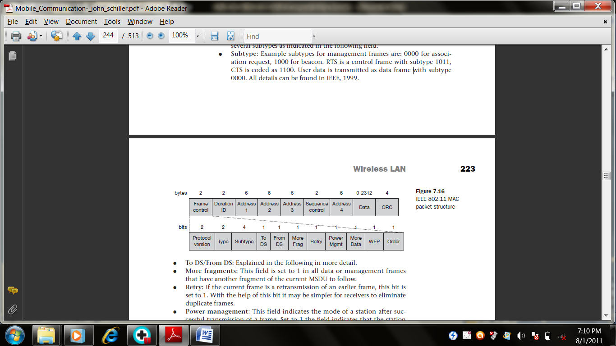
The frame control field shown in Figure contains the following fields:
- Protocol version: This 2 bit field indicates the current protocol version and is fixed to 0 by now. If major revisions to the standard make it incompatible with the current version, this value will be increased.
- Type: The type field determines the function of a frame: management (=00), control (=01), or data (=10). The value 11 is reserved. Each type has several subtypes as indicated in the following field.
- Subtype: Example subtypes for management frames are: 0000 for association request, 1000 for beacon. RTS is a control frame with subtype 1011, CTS is coded as 1100. User data is transmitted as data frame with subtype 0000.
- To DS/From DS: It deals about the transmission of data.
- More fragments: This field is set to 1 in all data or management frames that have another fragment of the current MSDU to follow.
- Retry: If the current frame is a retransmission of an earlier frame, this bit is set to 1. With the help of this bit it may be simpler for receivers to eliminate duplicate frames.
- Power management: This field indicates the mode of a station after successful transmission of a frame. Set to 1 the field indicates that the station goes into power-save mode. If the field is set to 0, the station stays active.
- More data: In general, this field is used to indicate a receiver that a sender has more data to send than the current frame. This can be used by an access point to indicate to a station in power-save mode that more packets are buffered. Or it can be used by a station to indicate to an access point after being polled that more polling is necessary as the station has more data ready to transmit.
- Wired equivalent privacy (WEP): This field indicates that the standard security mechanism of 802.11 is applied. However, due to many weaknesses found in the WEP algorithm higher layer security should be used to secure an 802.11 network.
- Order: If this bit is set to 1 the received frames must be processed in strict order.

2.4.2 MAC management
MAC management plays a central role in an IEEE 802.11 station as it more or less controls all functions related to system integration, i.e., integration of a wireless station into a BSS, formation of an ESS, synchronization of stations etc.
The following functional groups have been identified and will be discussed in more detail in the following sections:
- Synchronization: Functions to support finding a wireless LAN, synchronization of internal clocks, generation of beacon signals.
- Power management: Functions to control transmitter activity for power conservation, e.g., periodic sleep, buffering, without missing a frame.
- Roaming: Functions for joining a network (association), changing access points, scanning for access points.
- Management information base (MIB): All parameters representing the current state of a wireless station and an access point are stored within a MIB for internal and external access. A MIB can be accessed via standardized protocols such as the simple network management protocol (SNMP).

3. IEEE 802.11b & 802.11a

3.1 IEEE 802.11b
IEEE 802.11b (IEEE 1999) was added as supplement to the original standard (Higher-speed physical layer extension in the 2.4 GHz band). This standard describes a new PHY layer and is by far the most successful version of IEEE 802.11 available today. The standards are named according to the order in which the respective study groups have been established. As the name of the supplement implies, this standard only defines a new PHY layer. Depending on the current interference and the distance between sender and receiver 802.11b systems offer 11, 5.5, 2, or 1 Mbit/s. Maximum user data rate is approx 6 Mbit/s. The lower data rates 1 and 2 Mbit/s use the 11-chip Barker sequence and DBPSK or DQPSK, respectively.
Figure shows two packet formats standardized for 802.11b. The mandatory format is called Long PLCP PPDU. The optional short PLCP PPDU format differs in several ways. The short synchronization field consists of 56 scrambled zeros instead of scrambled ones. The short start frame delimiter SFD consists of a mirrored bit pattern compared to the SFD of the long format: 0000 0101 1100 1111 is used for the short PLCP PDU instead of 11110011 1010 0000 for the long PLCP PPDU. Receivers that are unable to receive the short format will not detect the start of a frame (but will sense the medium is busy).
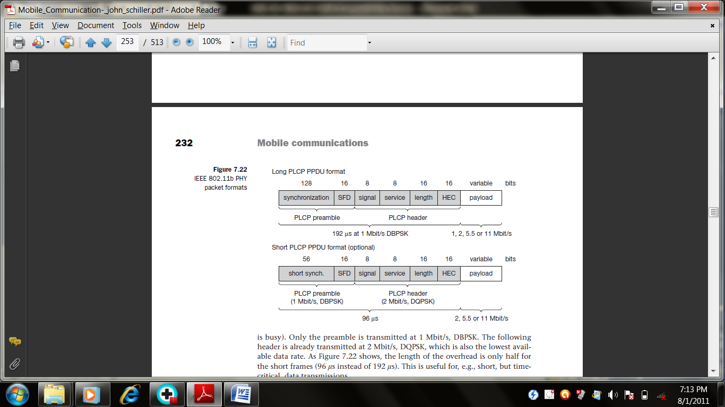
3.2 IEEE 802.11a
Initially aimed at the US 5 GHz U-NII (Unlicensed National Information Infrastructure) bands IEEE 802.11a offers up to 54 Mbit/s using OFDM (IEEE, 1999).
The physical layer of IEEE 802.11a and the ETSI standard HiperLAN2 has been jointly developed, so both physical layers are almost identical. It should be noted that most of the development for the physical layer for 802.11a was adopted from the HiperLAN2 standardization – but 802.11a products were available first and are already in widespread use.
Again, IEEE 802.11a uses the same MAC layer as all 802.11 physical layers do and, in the following, only the lowest layer is explained in some detail.
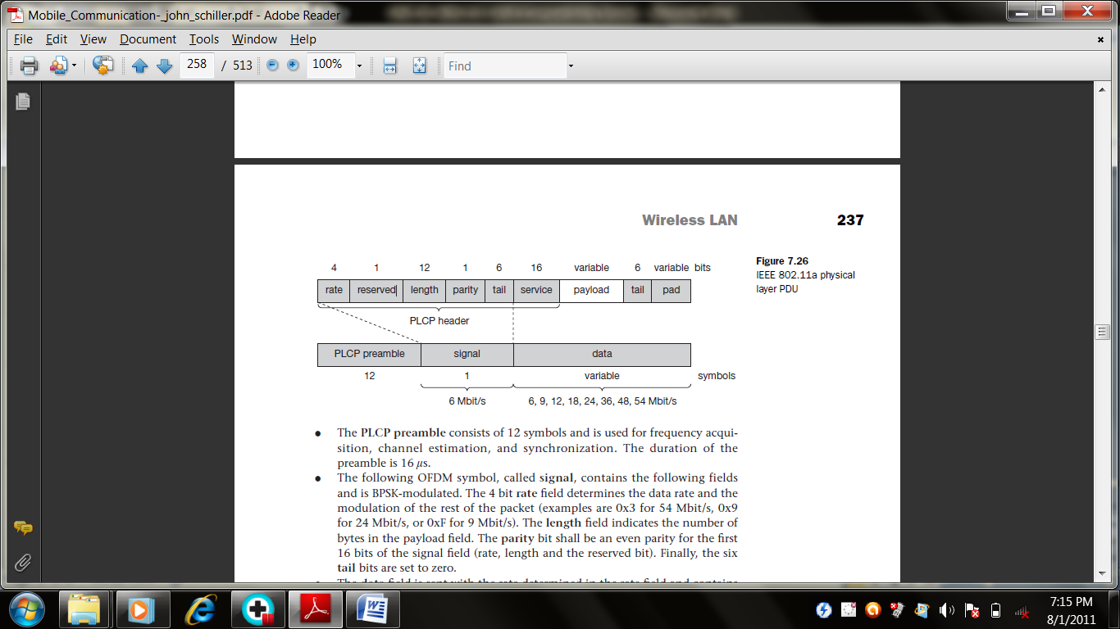

- The PLCP preamble consists of 12 symbols and is used for frequency acquisition, channel estimation, and synchronization. The duration of the preamble is 16 μs.
- The OFDM symbol, called signal, contains the following fields and is BPSK-modulated. The 4 bit rate field determines the data rate and the modulation of the rest of the packet. The length field indicates the number of bytes in the payload field. The parity bit shall be an even parity for the first 16 bits of the signal field (rate, length and the reserved bit). Finally, the six tail bits are set to zero.
- The data field is sent with the rate determined in the rate field and contains a service field which is used to synchronize the descrambler of the receiver) and which contains bits for future use. The payload contains the MAC PDU (1-4095 byte). The tail bits are used to reset the encoder. Finally, the pad field ensures that the number of bits in the PDU maps to an integer number of OFDM symbols.

4. HIPERLAN
In 1996, the ETSI standardized HIPERLAN 1 as a WLAN allowing for node mobility and supporting ad-hoc and infrastructure-based topologies. (HIPERLAN stands for high performance local area network.) HIPERLAN 1 was originally one out of four HIPERLANs envisaged, as ETSI decided to have different types of networks for different purposes. The key feature of all four networks is their integration of time-sensitive data transfer services. Over time, names have changed and the former HIPERLANs 2, 3, and 4 are now called HiperLAN2, HIPERACCESS, and HIPERLINK. The current focus is on HiperLAN2, a standard that comprises many elements from ETSI’s BRAN (broadband radio access networks) and wireless ATM activities.

Historical: HIPERLAN 1
ETSI (1998b) describes HIPERLAN 1 as a wireless LAN supporting priorities and packet life time for data transfer at 23.5 Mbit/s, including forwarding mechanisms, topology discovery, user data encryption, network identification and power conservation mechanisms. HIPERLAN 1 should operate at 5.1–5.3 GHz with a range of 50 m in buildings at 1 W transmit power. The service offered by a HIPERLAN 1 is compatible with the standard MAC services known from IEEE 802.x LANs. Addressing is based on standard 48 bit MAC addresses. A special HIPERLAN 1 identification scheme allows the concurrent operation of two or more physically overlapping HIPERLANs without mingling their communication. Confidentiality is ensured by an encryption/decryption algorithm that requires the identical keys and initialization vectors for successful decryption of a data stream encrypted by a sender.
An innovative feature of HIPERLAN 1, which many other wireless networks do not offer, is its ability to forward data packets using several relays. Relays can extend the communication on the MAC layer beyond the radio range. For power conservation, a node may set up a specific wake-up pattern. This pattern determines at what time the node is ready to receive, so that at other times, the node can turn off its receiver and save energy. These nodes are called p-savers and need so-called p-supporters that contain information about the wake-up patterns of all the p-savers they are responsible for. A p-supporter only forwards data to a p-saver at the moment the p-saver is awake. This action also requires buffering mechanisms for packets on p-supporting forwarders.
The following describes only the medium access scheme of HIPERLAN 1, a scheme that provides QoS and a powerful prioritization scheme. However, it turned out that priorities and QoS in general are not that important for standard LAN applications today. IEEE 802.11 in its standard versions does not offer priorities, the optional PCF is typically not implemented in products – yet 802.11 is very popular.
Elimination-yield non-preemptive priority multiple access (EY-NPMA) is not only a complex acronym, but also the heart of the channel access providing priorities and different access schemes. EY-NPMA divides the medium access of different competing nodes into three phases:
- Prioritization: Determine the highest priority of a data packet ready to be sent by competing nodes.
- Contention: Eliminate all but one of the contenders, if more than one sender has the highest current priority.
- Transmission: Finally, transmit the packet of the remaining node. In a case where several nodes compete for the medium, all three phases are necessary (called ‘channel access in synchronized channel condition’). If the channel is free for at least 2,000 so-called high rate bit-periods plus a dynamic extension, only the third phase, i.e. transmission, is needed (called ‘channel access in channel-free condition’).
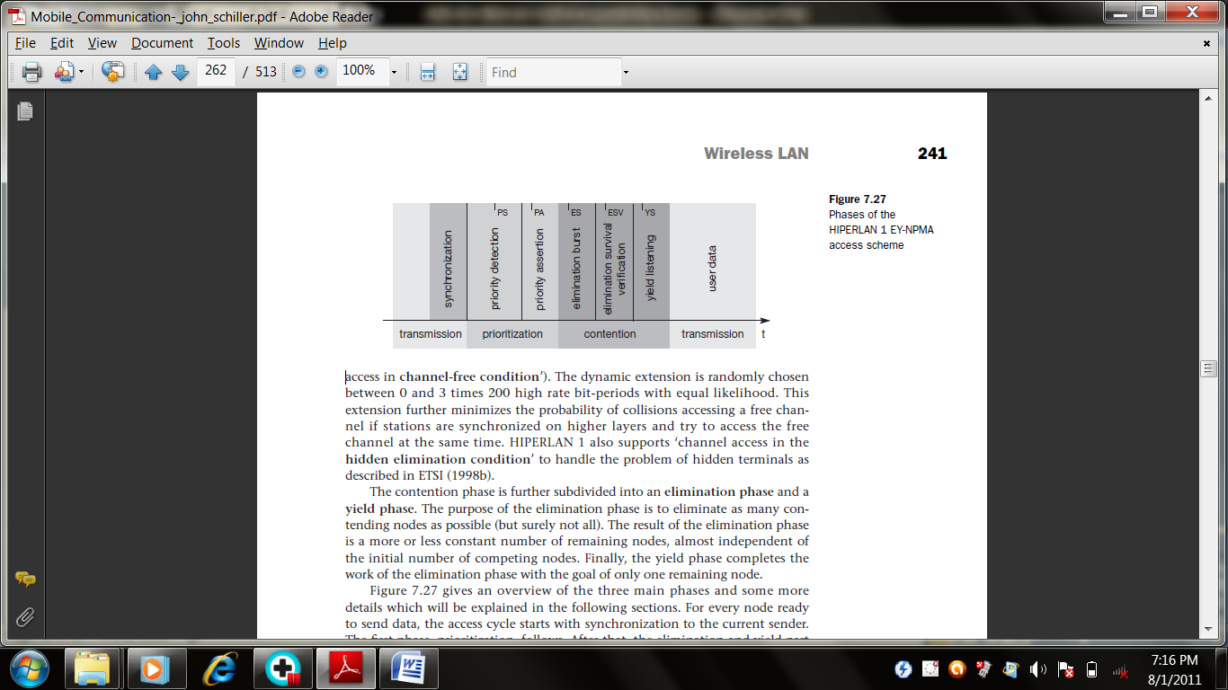

The dynamic extension is randomly chosen between 0 and 3 times 200 high rate bit-periods with equal likelihood. This extension further minimizes the probability of collisions accessing a free channel if stations are synchronized on higher layers and try to access the free channel at the same time. HIPERLAN 1 also supports ‘channel access in the hidden elimination condition’ to handle the problem of hidden terminals as described in ETSI (1998b).
The contention phase is further subdivided into an elimination phase and a yield phase. The purpose of the elimination phase is to eliminate as many contending nodes as possible (but surely not all). The result of the elimination phase is a more or less constant number of remaining nodes, almost independent of the initial number of competing nodes. Finally, the yield phase completes the work of the elimination phase with the goal of only one remaining node.
For every node ready to send data, the access cycle starts with synchronization to the current sender. The first phase, prioritization, follows. After that, the elimination and yield part of the contention phase follow. Finally, the remaining node can transmit its data. Every phase has a certain duration which is measured in numbers of slots and is determined by the variables I_{PS}, I_{PA}, I_{ES}, I_{ESV}, and I_{YS}.

4.1 Prioritization phase
HIPERLAN 1 offers five different priorities for data packets ready to be sent. After one node has finished sending, many other nodes can compete for the right to send. The first objective of the prioritization phase is to make sure that no node with a lower priority gains access to the medium while packets with higher priority are waiting at other nodes. This mechanism always grants nodes with higher priority access to the medium, no matter how high the load on lower priorities.
In the first step of the prioritization phase, the priority detection, time is divided into five slots, slot 0 (highest priority) to slot 4 (lowest priority). Each slot has a duration of I_{PS} = 168 high rate bit-periods. If a node has the access priority p, it has to listen into the medium for p slots (priority detection). If the node senses the medium is idle for the whole period of p slots, the node asserts the priority by immediately transmitting a burst for the duration I_{PA} = 168 high rate bit-periods (priority assertion).

4.2 Elimination phase
Several nodes may now enter the elimination phase. Again, time is divided into slots, using the elimination slot interval I_{ES} = 212 high rate bit periods. The length of an individual elimination burst is 0 to 12 slot intervals long, the probability of bursting within a slot is 0.5.
The elimination phase now resolves contention by means of elimination bursting and elimination survival verification. Each contending node sends an elimination burst with length n as determined via the probabilities and then listens to the channel during the survival verification interval I_{ESV} = 256 high rate bit periods. The burst sent is the same as for the priority assertion. A contending node survives this elimination phase if, and only if, it senses the channel is idle during its survival verification period. Otherwise, the node is eliminated and stops its attempt to send data during this transmission cycle.
The whole elimination phase will last for the duration of the longest elimination burst among the contending nodes plus the survival verification time. One or more nodes will survive this elimination phase, and can then continue with the next phase.

4.3 Yield phase
During the yield phase, the remaining nodes only listen into the medium without sending any additional bursts. Again, time is divided into slots, this time called yield slots with a duration of I_{YS} = 168 high rate bit-periods. The length of an individual yield listening period can be 0 to 9 slots with equal likelihood. Each node now listens for its yield listening period. If it senses the channel is idle during the whole period, it has survived the yield listening. Otherwise, it withdraws for the rest of the current transmission cycle. This time, the length of the yield phase is determined by the shortest yield-listening period among all the contending nodes. At least one node will survive this phase and can start to transmit data. This is what the other nodes with longer yield listening period can sense. It is important to note that at this point there can still be more than one surviving node so a collision is still possible.

4.4 Transmission phase
A node that has survived the prioritization and contention phase can now send its data, called a low bit-rate high bit-rate HIPERLAN 1 CAC protocol data unit (LBR-HBR HCPDU). This PDU can either be multicast or unicast.

5. BLUETOOTH
The Bluetooth technology is also called as ad-hoc piconets, which are local area networks with a very limited coverage and without the need for an infrastructure. This is a different type of network, needed to connect different small devices in close proximity (about 10 m to 100m) without expensive wiring or the need for a wireless infrastructure. The envisaged gross data rate is 1 Mbit/s, asynchronous (data) and synchronous (voice) services should be available.
Many of today’s devices offer an infra red data association (IrDA) interface with transmission rates of, e.g., 115 kbit/s or 4 Mbit/s. There are various problems with IrDA: its very limited range (typically 2 m for built-in interfaces), the need for a line-of-sight between the interfaces, and, it is usually limited to two participants, i.e., only point-to-point connections are supported. IrDA has no internetworking functions, has no media access, or any other enhanced communication mechanisms. The big advantage of IrDA is its low cost, and it can be found in almost any mobile device (laptops, PDAs, mobile phones).

5.1 User scenarios
Many different user scenarios can be imagined for wireless piconets or wireless personal area networks WPANs:
- Connection of peripheral devices: Today, most devices are connected to a desktop computer via wires (e.g., keyboard, mouse, joystick, headset, speakers). This type of connection has several disadvantages. In a wireless network, no wires are needed for data transmission.
- Support of ad-hoc networking: Imagine several people coming together, discussing issues, exchanging data (schedules, sales figures etc.). Wireless networks can support this type of interaction; small devices might not have WLAN adapters following the IEEE 802.11 standard, but cheaper Bluetooth chips built in.
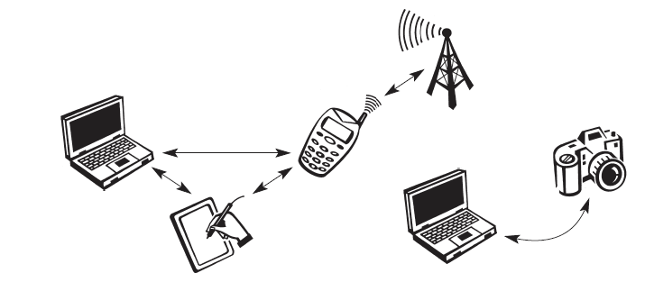
- Bridging of networks: Using wireless piconets, a mobile phone can be connected to a PDA or laptop in a simple way. Mobile phones will not have full WLAN adapters built in, but could have a Bluetooth chip. The mobile phone can then act as a bridge between the local piconet and, e.g., the global GSM network. For instance, on arrival at an airport, a person’s mobile phone could receive e-mail via GSM and forward it to the laptop which is still in a suitcase. Via a piconet, a fileserver could update local information stored on a laptop or PDA while the person is walking into the office.

5.2 Networking
To understand the networking of Bluetooth devices a quick introduction to its key features is necessary. Bluetooth operates on 79 channels in the 2.4 GHz band with 1 MHz carrier spacing. Each device performs frequency hopping with 1,600 hops/s in a pseudo random fashion. Bluetooth applies FHSS for interference mitigation (and FH-CDMA for separation of networks).
A very important term in the context of Bluetooth is a piconet. A piconet is a collection of Bluetooth devices which are synchronized to the same hopping sequence. Figure, shows a collection of devices with different roles. One device in the piconet can act as master (M), all other devices connected to the master must act as slaves (S). The master determines the hopping pattern in the piconet and the slaves have to synchronize to this pattern. Each piconet has a unique hopping pattern. If a device wants to participate it has to synchronize to this. Two additional types of devices are shown: parked devices (P) can not actively participate in the piconet (i.e., they do not have a connection), but are known and can be reactivated within some milliseconds.
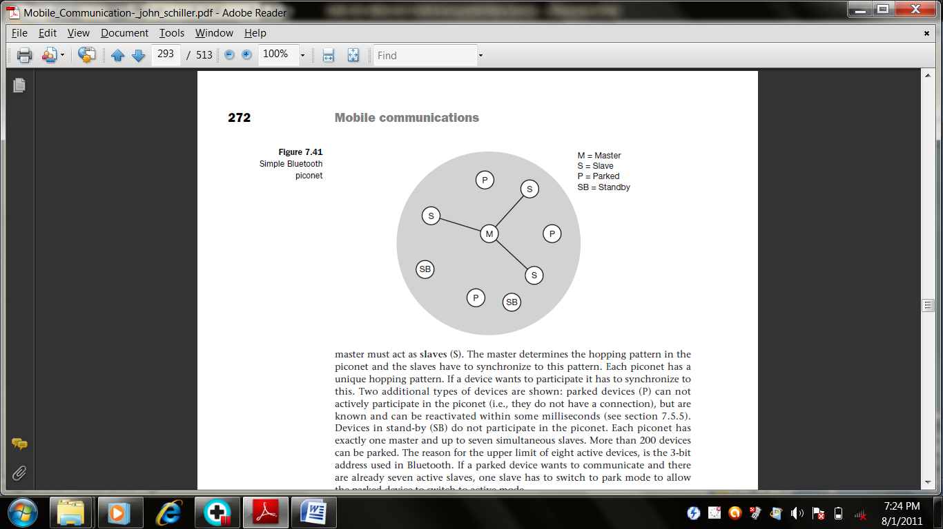
Devices in stand-by (SB) do not participate in the piconet. Each piconet has exactly one master and up to seven simultaneous slaves. More than 200 devices can be parked. The reason for the upper limit of eight active devices, is the 3-bit address used in Bluetooth. If a parked device wants to communicate and there are already seven active slaves, one slave has to switch to park mode to allow the parked device to switch to active mode.

5.3 Protocol stack
The Bluetooth protocol stack can be divided into a core specification, which describes the protocols from physical layer to the data link control together with management functions, and profile specifications.
The core protocols of Bluetooth comprise the following elements:
- Radio: Specification of the air interface, i.e., frequencies, modulation, and transmit power .
- Baseband: Description of basic connection establishment, packet formats, timing, and basic QoS parameters
- Link manager protocol: Link set-up and management between devices including security functions and parameter negotiation
- Logical link control and adaptation protocol (L2CAP): Adaptation of higher layers to the baseband.
- Service discovery protocol: Device discovery in close proximity plus querying of service characteristics.

5.4 Physical links:
Bluetooth offers two different types of links, a synchronous connection-oriented link and an asynchronous connectionless link:
- Synchronous connection-oriented link (SCO): Classical telephone (voice) connections require symmetrical, circuit-switched, point-to-point connections. For this type of link, the master reserves two consecutive slots (forward and return slots) at fixed intervals. A master can support up to three simultaneous SCO links to the same slave or to different slaves. A slave supports up to two links from different masters or up to three links from the same master.
- Asynchronous connectionless link (ACL): Typical data applications require symmetrical or asymmetrical (e.g., web traffic), packet-switched, point-to-multipoint transfer scenarios (including broadcast). Here the master uses a polling scheme. A slave may only answer if it has been addressed in the preceding slot. Only one ACL link can exist between a master and a slave.

5.5 Link manager protocol: (Different States of Bluetooth)
The link manager protocol (LMP) manages various aspects of the radio link between a master and a slave and the current parameter setting of the devices. LMP enhances baseband functionality, but higher layers can still directly access the baseband. The following groups of functions are covered by the LMP:
- Authentication, pairing, and encryption: Although basic authentication is handled in the baseband, LMP has to control the exchange of random numbers and signed responses. The pairing service is needed to establish an initial trust relationship between two devices that have never communicated before. The result of pairing is a link key. This may be changed, accepted or rejected. LMP is not directly involved in the encryption process, but sets the encryption mode, key size, and random speed.
- Synchronization: The clock offset is updated each time a packet is received from the master. Additionally, special synchronization packets can be received. Devices can also exchange timing information related to the time differences (slot boundaries) between two adjacent piconets.
- Capability negotiation: Not only the version of the LMP can be exchanged but also information about the supported features. Not all Bluetooth devices will support all features that are described in the standard, so devices have to agree the usage of, e.g., multi-slot packets, encryption, SCO links, voice encoding, park/sniff/hold mode, HV2/HV3 packets etc.
- Quality of service negotiation: Different parameters control the QoS of a Bluetooth device at these lower layers. The poll interval, i.e., the maximum time between transmissions from a master to a particular slave, controls the latency and transfer capacity.
- Power control: A Bluetooth device can measure the received signal strength. Depending on this signal level the device can direct the sender of the measured signal to increase or decrease its transmit power.
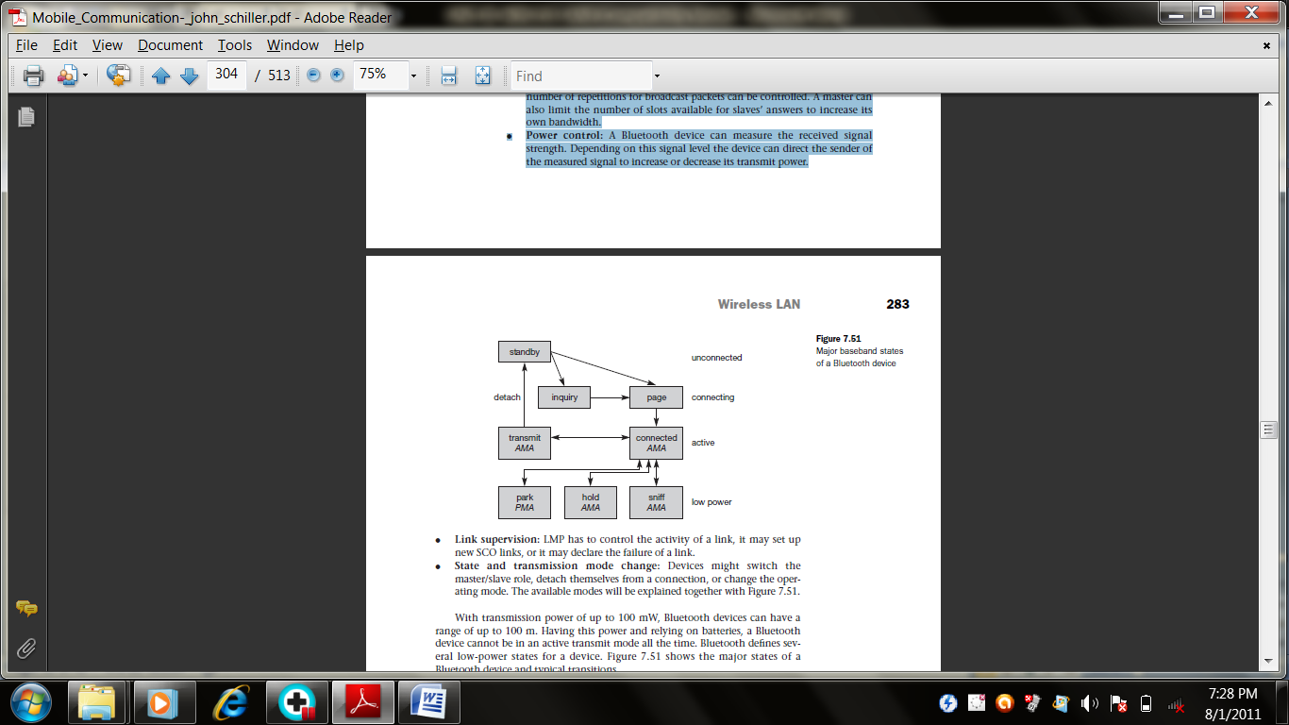

- Link supervision: LMP has to control the activity of a link, it may set up new SCO links, or it may declare the failure of a link.
- State and transmission mode change: Devices might switch the master/slave role, detach themselves from a connection, or change the operating mode. With transmission power of up to 100 mW, Bluetooth devices can have a range of up to 100 m. Having this power and relying on batteries, a Bluetooth device cannot be in an active transmit mode all the time. Bluetooth defines several low-power states for a device. Every device, which is currently not participating in a piconet (and not switched off), is in standby mode. This is a low-power mode where only the native clock is running. The next step towards the inquiry mode can happen in two different ways. Either a device wants to establish a piconet or a device just wants to listen to see if something is going on.
- A device wants to establish a piconet: A user of the device wants to scan for other devices in the radio range. The device starts the inquiry procedure by sending an inquiry access code (IAC) that is common to all Bluetooth devices. The IAC is broadcast over 32 so-called wake-up carriers in turn.
- Devices in standby that listen periodically: Devices in standby may enter the inquiry mode periodically to search for IAC messages on the wake-up carriers. As soon as a device detects an inquiry it returns a packet containing its device address and timing information required by the master to initiate a connection. From that moment on, the device acts as slave.

If the inquiry was successful, a device enters the page mode. The inquiry phase is not coordinated; inquiry messages and answers to these messages may collide, so it may take a while before the inquiry is successful. After a while (typically seconds but sometimes up to a minute) a Bluetooth device sees all the devices in its radio range.
During the page state two different roles are defined. After finding all required devices the master is able to set up connections to each device, i.e., setting up a piconet. Depending on the device addresses received the master calculates special hopping sequences to contact each device individually. The slaves answer and synchronize with the master’s clock, i.e., start with the hopping sequence defined by the master. The master may continue to page more devices that will be added to the piconet. As soon as a device synchronizes to the hopping pattern of the piconet it also enters the connection state.
The connection state comprises the active state and the low power states park, sniff, and hold. In the active state the slave participates in the piconet by listening, transmitting, and receiving. ACL and SCO links can be used. A master periodically synchronizes with all slaves. All devices being active must have the 3-bit active member address (AMA). Within the active state devices either transmit data or are simply connected. A device can enter standby again, via a detach procedure To save battery power, a Bluetooth device can go into one of three low power states:
- Sniff state: The sniff state has the highest power consumption of the low power states. Here, the device listens to the piconet at a reduced rate. The interval for listening into the medium can be programmed and is application dependent. The master designates a reduced number of slots for transmission to slaves in sniff state. However, the device keeps its AMA.
- Hold state: The device does not release its AMA but stops ACL transmission. A slave may still exchange SCO packets. If there is no activity in the piconet, the slave may either reduce power consumption or participate in another piconet.
- Park state: In this state the device has the lowest duty cycle and the lowest power consumption. The device releases its AMA and receives a parked member address (PMA). The device is still a member of the piconet, but gives room for another device to become active (AMA is only 3 bit, PMA 8 bit).Parked devices are still FH synchronized and wake up at certain beacon intervals for re-synchronization. All PDUs sent to parked slaves are broadcast. The intervals in sniff mode also influence power consumption. Typical IEEE 802.11b products have an average current in the order of 200 mA while receiving, 300 mA while sending, and 20 mA in standby.

5.5 Security
The main security features offered by Bluetooth include a challenge response routine for authentication, a stream cipher for encryption, and a session key generation. Each connection may require a one-way, two-way, or no authentication using the challenge-response routine. All these schemes have to be implemented in silicon, and higher layers should offer stronger encryption if needed. The security features included in Bluetooth only helps to set up a local domain of trust between devices. The security algorithms use the public identity of a device, a secret private user key, and an internally generated random key as input parameters. For each transaction, a new random number is generated on the Bluetooth chip. Key management is left to higher layer software.

PART –A
- What is the purpose of MAC management?
- List out the 3 basic access mechanisms defined for the IEEE 802.11.
- What are the elements present in the core protocols of Bluetooth?
- Differentiate channel access in synchronized channel condition and in synchronized channel condition.
- Write a short note on adhoc piconets.
- How the mobile phone can act as a bridge between the networks?
- Define Short inter-frame spacing (SIFS).
- Draw the frame format for Long PLCP PPDU.
- Mention the disadvantages of IrDA.
- What are the main goals of WLAN?
PART-B
- i) Mention the design goal, advantages and disadvantages of WLAN.(4)
ii)Discuss in detail about the IR Vs Radio transmission and Infrastructure & Adhoc networks. (12)
- Describe the system and protocol architecture of the IEEE 802.11.(16)
- Explain the concept of IEEE 802.11 physical layer in detail with frame format.
- Discuss the following,
i)MAC layer and management(6) ii)MAC Frames(10)
- Write a detailed notes on HIPERLAN and its phases.(16)
- Explain about the various states of Bluetooth and its networking process.(16)

